

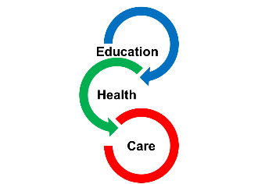

Appendix 1B

Voice of Parents and Carer’s Form for an Education, Health and Care Plan (EHCP)

Below, is our Children’s and Young People’s Outcome Framework. We use this to ensure that the provision in place to support your child/young person, is having a positive impact on their life, from your perspective. You may wish to complete this section independently, with a partner or friend, or with the support of a familiar professional.

Your child or young person will have the opportunity to complete a similar form (Appendix 1A), so their voice is also captured. This can be done at school, or at home.

If your child or young person is issued with an EHCP, you will be given the opportunity to update this section, each year, as part of the Annual Review process.
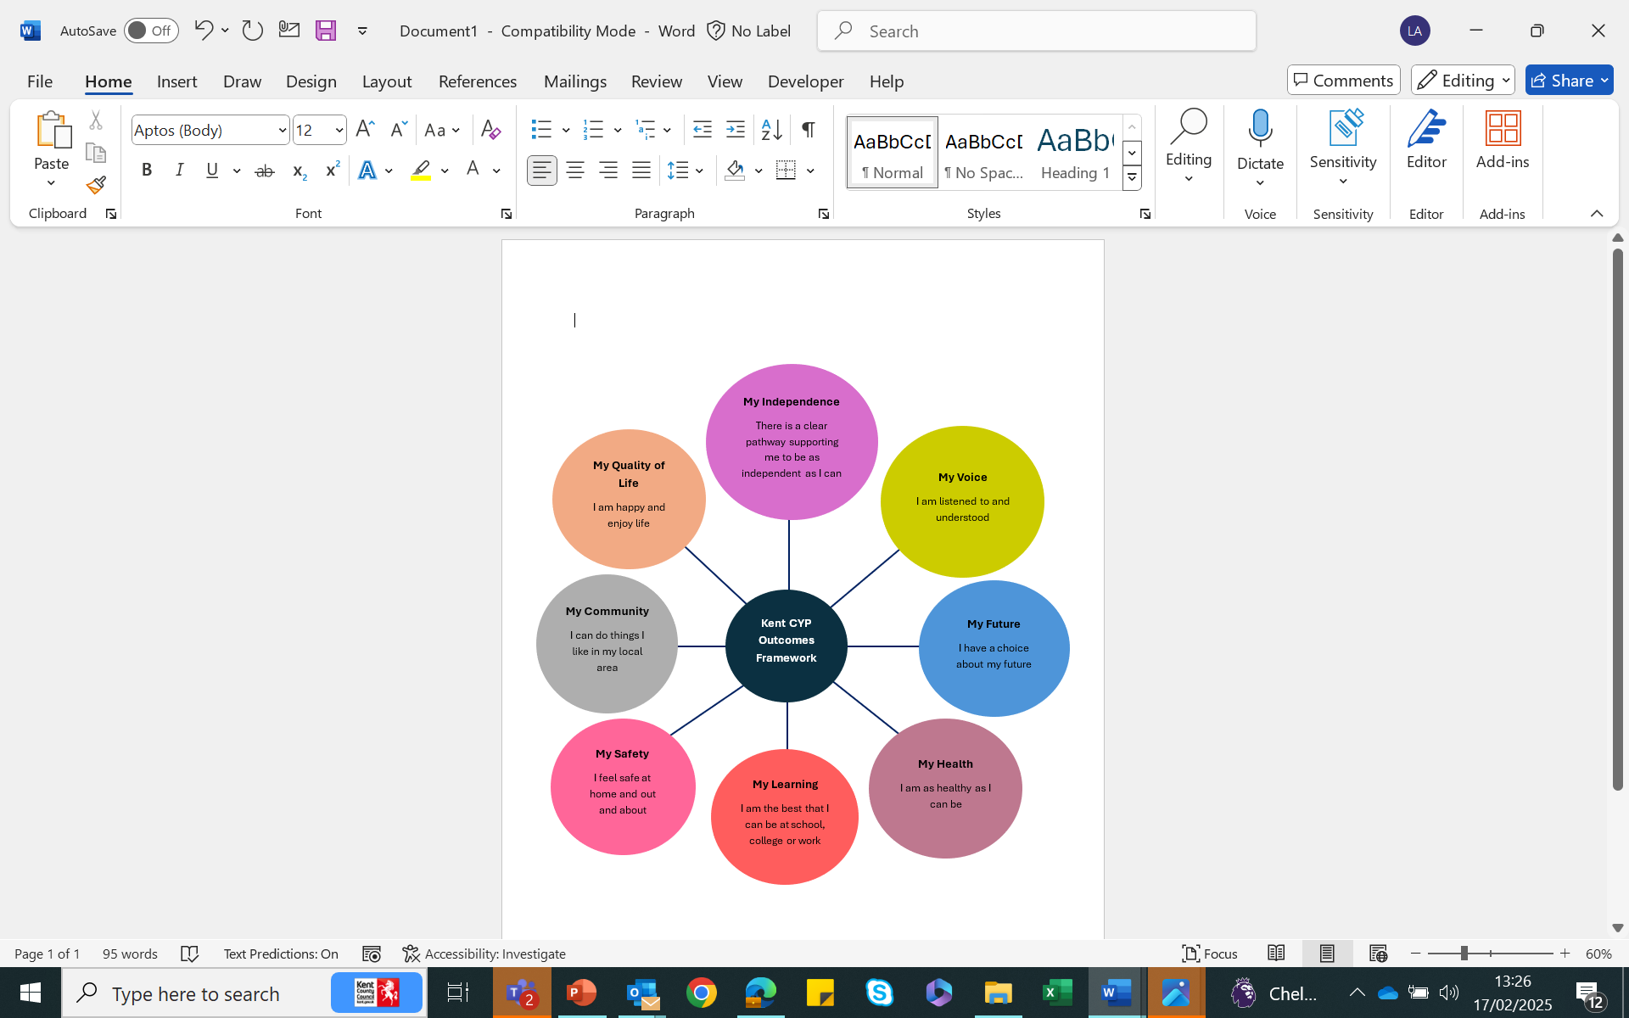

Personal Details of Child/Young Person (Please check that the details of your Child / Young Person are correct.)
First Name:
Last Name:
Preferred Name:
Date of Birth:
National Curriculum Year:
Gender:
Religion:
Language used at Home (Is an interpreter needed?):

Preferred way of communicating (e.g. verbal communication, signing):

Looked After Child? Yes or No
If yes, to which Local Authority:
Address:

Current school or setting:

Name of Parent/Carer:

Parent/Carer Contact details:
Phone:
Email:
Address (if different from above):

Name of Parent/Carer 2:

Parent/Carer contact details:
Phone:
Email:
Address (if different from above):

GP Name and Contact details:

Our hopes for our Child / Young Person in the future:

What you would like your Child / Young Person to achieve by the time they are an adult (if appropriate)?

(e.g., to achieve qualifications, to be able to live independently, to be able to have a job, to be happy, etc.)
Comments:

What you would like your Child / Young Person to have achieved in a year’s time, by their next Annual Review?

(e.g., to be able to be less anxious in school, to be able to attend school more regularly, to be more independent with learning, to increase safety-awareness when crossing roads, to be able to indicate to a member of staff when help is needed, etc.)

*Please write ‘N/A’ if your child is going through an Education, Health and Care Needs Assessment (EHCNA) and does not currently have a finalised Education, Health and Care Plan (EHCP).
Comments:

A Summary of your Child’s / Young Person’s Education Needs:

Please indicate ü below which external support you are aware of, which the school has accessed, to date, to support your child or young person’s SEN needs. You may wish to discuss this information with your child’s educational setting, if you are unsure.

Specialist Nursery Intervention  (Early Years)  ☐ | SENIF Practitioner and/or SENIF Funding  (Early Years)  ☐ | Portage  (Early Years)  ☐ | Local Inclusion Forum Teams  (LIFT)  ☐ | Kent and Medway Communication and Assistive Technology Service  (KM CAT Team)  ☐ | Specialist Teaching and Learning Services (STLS)  ☐
Sensory Specialist Teaching Services (Visual/Hearing/Multi-Sensory Impairment)  ☐ | Support from Kent’s Education Psychology Services (KEPs)  ☐ | Virtual School Kent (VSK)  ☐ | Counselling or Therapeutic Support (e.g., ELSA, Play Therapy, Thrive)  ☐ | High Needs Funding  ☐ | SEN Inclusion Advisor Support  ☐
Suspension / Permanent Exclusions  ☐ | Kent’s PRU and  Attendance Service (KPAS)  ☐ | Reduced Timetable, within the educational setting  ☐ | Kent Health Needs  ☐ | Other  ☐ | I am unsure of the services my child/young person is open to  ☐

Comments: (e.g., you may wish to include: previous setting/s your child has attended, when your child/young person was first put on the SEN Register, or Educational Professionals your child / young person is open to or supported, if not listed above.)

A Summary of your Child’s / Young Person’s Health Needs:

Please provide any medical diagnoses, referrals, or pathways your child is currently on.

(e.g., Autism Spectrum Disorder (ASD) diagnosis, Attention Deficit Hyperactivity Disorder (ADHD) pathway; or any medical conditions which require management in the educational setting; e.g., epi-pen/asthma pump/Emergency Medication.)

Please indicate ü below which health services your child is currently open to:

Paediatrician  ☐ | Health Visitor  ☐ | Speech and Language Therapist (SALT)  ☐ | Occupational Therapist  (OT)  ☐ | Specialist consultants  ☐
Any of the Children and Adolescent Mental Health Services (CAMHS)  ☐ | School Nursing Team  ☐ | Physiotherapist  ☐ | Children’s Care Team Coordinators  ☐ | Other  ☐

Comments: (e.g., you may wish to include difficulties with vision, hearing, or mobility; any medical needs /prescribed medication; or previously closed services.)

A Summary of your Child’s / Young Person’s Social Care Needs:

Please indicate ü below which social care services your child is currently open to:

Early Help  ☐ | Children’s Social Work  Service  ☐ | Leaving Care  Service  ☐ | Adolescent  Service  ☐
Strengthening Independence  Service  ☐ | Disabled Children’s  Service  ☐ | Adult Services  ☐ | Youth Justice Service  ☐

Comments: (e.g., their specific Social Care needs; any Social Care professionals (Early Help, Social Services) your child / young person is open to.)

Our views about what is working well; what needs to stay the same and what needs to change.

What is working well:

What needs to stay the same:

What needs to change:

Is there anything else you would like to share?
(e.g., any significant circumstances / events in your child’s / young person’s life (moving house, birth of a new sibling, divorce, etc.)

My Child’s / Young Person’s School / Setting experience, overall:

My child’s or young person’s… | Outcomes | My views
Future | I feel that my child or young person has a choice about their future.
Independence | I feel that my child or young person has the appropriate support to enable them to be as independent as they can be.
Voice | I feel that my child or young person has a voice and is listened to.
Health | I feel that my child or young person has the appropriate health support to enable them to be as healthy as they can be.
Learning and Support | I feel that my child has the appropriate amount of support at school or in their setting.
Safety | I feel that my child or young person feels safe.
Community | I feel that my child or young person has a sense of belonging.
Quality of life | I feel that my child or young person is happy and enjoys life.

Date of completed form:
Click or tap to enter a date.

