Budget Monitoring Overview
Budget Monitoring on the Budget Planning Software (BPS) is performed at Cost Centre level using the Budget Monitoring menu and selecting the Cost Centre Budget Profile sub menu.
In order to monitor at Cost Centre level a Cost Centre Allocation report (referred to as the CCAC) must be created for the Original, submitted Budget i.e. the one that was approved by Governors. This is so that monitoring can be created by cost centre.
Note: If changes need to be made to the submitted budget the CCAC report must be created again using a copy of the submitted budget.
Once a CCAC for the submitted budget (or copy of the submitted if changes have been made) has been created and saved, the Budget Forecast used can then be selected in the Cost Centre Budget Profile. No other Cost Centre Allocation reports will be required for monitoring purposes.
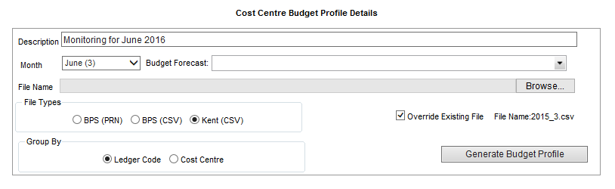
2016/17 Submitted Budget
The Budget Forecast selected in the Cost Centre Budget Profile will populate all of the Original Budget columns as well as the Calculated Remaining in the Revenue and Capital tabs.
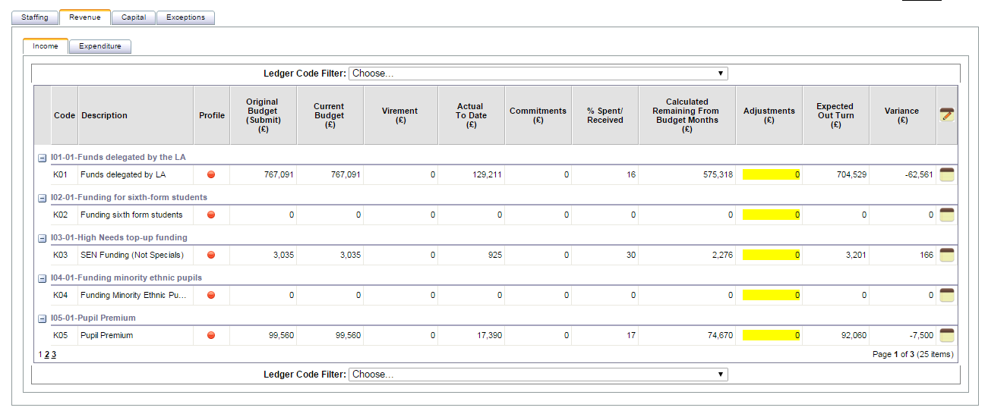
The Original Budget column in the STAFFING TAB is also taken from this CCAC however the Calculated Remaining from Budget Months column is populated from the Employee Scenario within your working copy (which has been set as current).
Having made amendments or adjustments to the Employee Scenario within your working copy please remember to repopulate (as per the Guidance) to ensure the correct information is pulled through to your monitoring forecast/document.
Further details on the above can be found within the documents stored in the Help and User Guidance area of the BPS.

