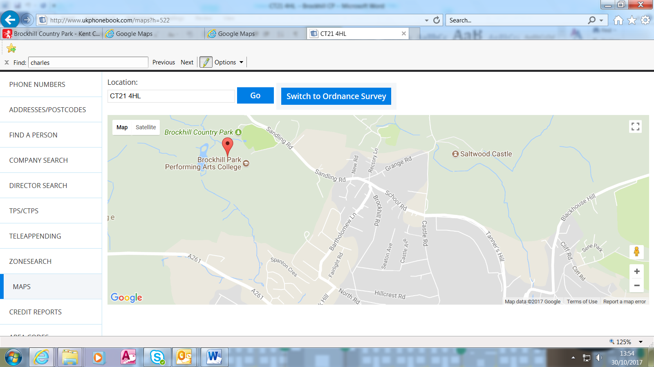

Address: Brockhill Country Park, Sandling Road, Saltwood, Nr Hythe CT21 4HL

Map:
This is for your reference when travelling to this site and parking your vehicles.
Refreshments:
Please be aware that there will be no refreshments available on the day
therefore you must make your own provisions for lunch.
There is a café on site – it opens from 10am – 4pm.

Parking:
Parking for delegates is free.
Important note: ANPR (Automatic Number Plate Recognition) operates at Brockhill Country Parks – all delegates attending the meeting must provide their name and vehicle registration number, written clearly on the sheet that will be in the Badger Room on the day of the meeting. Failure to provide the correct vehicle registration number will result in a fine being issued by Euro car parks.

