Schools in Kent –Woodlands for Schools - A Call for Sites

As part of ‘Plan Tree’, Kent County Councils Tree Establishment Strategy, we are launching a tree scheme called ‘Woodlands for Schools’ which will be funded by the Local Authority Treescape Fund for 2023 and 2024.

The UK needs millions more trees to reach its 2050 carbon net-zero target. By planting with us, you'll help bring us nearer to this important goal. This is a great opportunity to get more local people engaged with our ambition to see the county’s tree cover extended by 1.5 million, establishing one new tree for every resident living in the county.

The first step is to identify an area of land on either the school grounds, land the school has arranged regular access to or in an area that is publicly accessible.

For example:
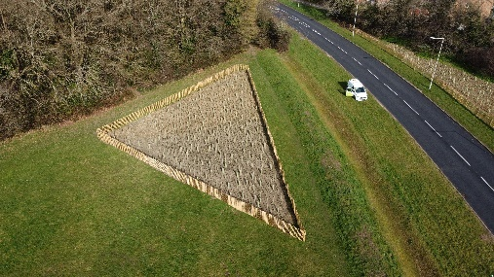 | 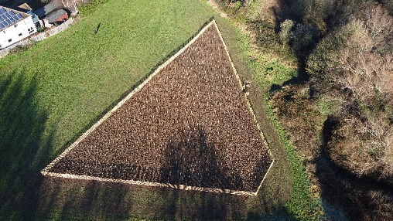 | 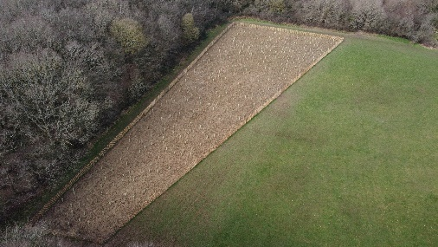

The trees can be planted as wildwoods, avenues, windbreaks, thickets, and Miyawaki forests. We are looking for areas of land from the size of a tennis court up to about half a football pitch. The maximum size we can plant is 0.5ha, which is just over an acre (70m x 70m).

Introducing the Miyawaki method (Video 1): https://youtu.be/I-9i0GiSF-s

The ‘Miyawaki method’ was developed by Japanese botanist Dr Akira Miyawaki and aims to reconstruct indigenous woodlands, producing a rich, dense, and efficient pioneer woodland within 20–30 years. Dr Miyawaki found trees naturally grew much faster if planted closer together. The method utilises a mix of approximately 30 native trees planted per 10m² (30 to 40 different species per site). They attract more wildlife species, with a substantial increase in noise and dust isolation. They also absorb 30 times as much carbon as a normal forest.

The Forest of Thanks (Video 2): https://youtu.be/I_bzjpnYs5I#

Once we have identified land, Kent County Council will collaborate with our local community groups and tree wardens to develop the idea, prepare the site, and help each school organise a successful planting event. You will also receive planting instructions and aftercare advice.

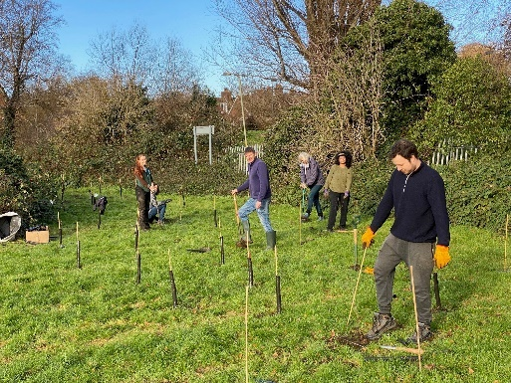 | 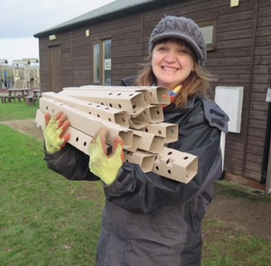 | 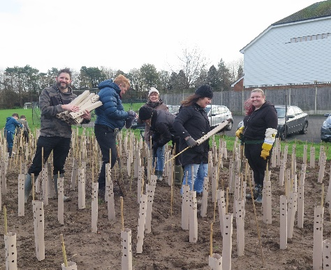

Schools should be prepared to water the trees and maintain each site for at least the first three years after planting.

If you are interested and have an area of land in mind, please use the following template to outline your ‘Woodlands for Schools’ project proposal:
Name |  |  | School
Position |  |  | Address
Telephone
Email |  |  | Legal Landowner
Brief outline of proposed project:

Size of proposed site
Sq. metres (m²)
Description of Land (current land use)
Details of accessibility and public right of way
Site location  https://gridreferencefinder.com/ |  | X - OS grid ref. |  | Y - OS grid ref. |  | What3Words
Site location
(nearest postcode)
Proximity to a water supply and infrastructure (cables / roads / houses)
Map of area (google map image)

Is your planting time critical – if so, please detail timescales and reasons
Any other comments or important considerations (partnerships, sponsorships, volunteer groups, funding availability)
Please let us if you need to seek any permissions/approval for this planting (and provide details if applicable)
Digital Signature |  |  |  |  |  | Date
If you have any questions regarding the proposal template, or project details please contact the Plan Tree Partnership Officer, at: lyndsay.wayman-rook@kent.gov.uk

