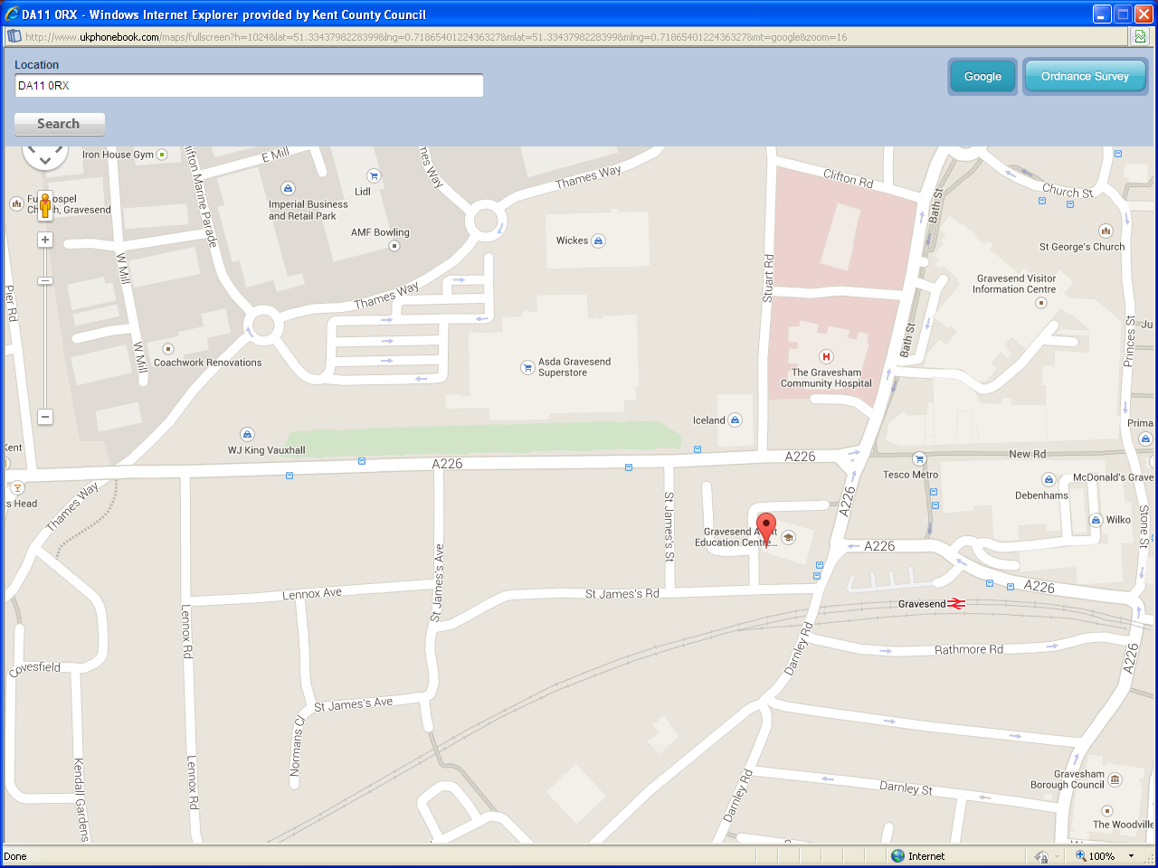
Map:
This is for your reference when travelling to this site and parking your vehicles.
Address: Gravesend AEC, Darnley Rd, Gravesend DA11 0RX

Refreshments:
Please be aware that there will be no refreshments available on the day, therefore you must make your own provisions for lunch.
There are local outlets nearby where you can purchase refreshments.
There is an onsite café which will be open to purchase refreshments.

Parking:
There is no visitors parking on site - but there are plenty of local car parks nearby- in the town centre – it is also walking distance from Gravesend train station.

