Special Educational Needs and Disabilities (SEND) Information Report

[Insert school name]

Delete and   
replace with   
school logo

**Inclusion Team**

**SEND Governor:**

XXXXXX

**Inclusion Lead/SENCO/SEND Team:**

XXXXXX

Contact No. XXXXXXXXXXX

**Inclusion Team:**  
XXXXXXXXX

[email@school.sch.uk](mailto:email@school.sch.uk)

|  |  |  |
| --- | --- | --- |
| **Approved by:** | [Name] | **Date:** [Date] |
| **Last reviewed on:** | [Date] | |
| **Next review due by:** | [Date – note: this document should be updated **annually** and as soon as possible when any of the information in it changes] | |

# 

# Contents

1. What types of SEND does the school provide for? 4

2. Which staff will support my child? 5

3. What should I do if I think my child has SEND? 7

4. What happens if the school identifies a need? 8

5. How will the school measure my child’s progress? 9

6. How will I be involved in decisions made about my child’s education? 10

7. How will my child be involved in decisions made about their education? 11

8. How will the school adapt its teaching for my child? 12

9. How will the school evaluate whether the support in place is helping my child? 13

10. How will the school ensure my child has appropriate resources? 13

11. How will the school make sure my child is included in activities alongside pupils who don’t have SEND? 14

12. How does the school make sure the admissions process is fair for pupils with SEN or a disability? 15

13. How does the school support pupils with disabilities? 15

14. How will the school support my child’s mental health and emotional and social development? 16

15. What support is in place for looked-after and previously looked-after children with SEN? 16

16. What support will be available for my child as they transition between classes or settings or in preparing for adulthood? 17

17. What support is available for me and my family? (Local Offer) 18

18. What should I do if I have a complaint about my child’s SEND support? 19

19. Supporting Documents…………………………………………………………………………………………………………….19

20. Glossary 20

The SEND information report should be tailored to your school. Adapt the information in this template report to reflect your school’s approach to SEND provision.

The report is:

* **For parents**, so they understand how you will implement your policies and deliver provision for their child. Use language that is clear and straightforward
* **To be published online**. Think about the most effective way to present this information on your website. For example, consider including images or diagrams

Remember: when Ofsted inspects your school, it will expect to see that it’s compliant, accessible and accurately reflects what’s actually happening in the school.

Dear parents and carers,

The aim of this Information Report is to explain how we implement our SEND policy. In other words, we want to show you how SEND support works in our school.

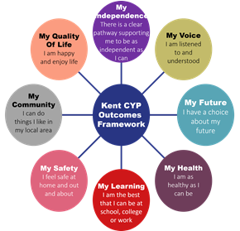As educational professionals, we are all working towards the ultimate goal of growing independent young people as they prepare for adulthood. All provision and support we provide is working towards achieving the Kent Children and Young People (CYP) Outcomes Framework:

If you want to know more about our arrangements for SEND, read our SEND policy alongside this Information Report.

You can find our SEND policy on our website [insert a link here].

**Note:** If there are any terms we’ve used in this information report that you’re unsure of, you can look them up in the Glossary at the end of the report.

# 1. What types of SEND does the school provide for?

Our school provides for pupils with the following needs (as outlined in the SEND Code of Practice 2015):

# A diagram of a child's development

Often you will find that children’s needs overlap and are rarely confined to one area of need, which is why it is important to gain a wholistic overview of your child.

More information about the Areas of Need can be found in the Special educational needs and disability code of practice: 0 to 25 years (link below).

[SEND_Code_of_Practice_January_2015.pdf (publishing.service.gov.uk)](https://assets.publishing.service.gov.uk/media/5a7dcb85ed915d2ac884d995/SEND_Code_of_Practice_January_2015.pdf)

# 2. Which staff will support my child, and what are their key responsibilities?

At (name school) all staff are considered responsible for supporting the needs of pupils with SEND. Our staff are committed to regular, high-quality training to ensure that they have the knowledge and skills to better meet a wide range of pupil needs.

Below outlines key staff who will be supporting your child. *Please note that this list is not exhaustive.*

Use this space to introduce parents to your SEND / inclusion team. It might be nice to include photos, and a little bio (although not necessary) / flow chart of staff outline who is who and what their roles are.

Our Special Educational Needs Co-ordinator, or SENCO

The named SENCO is XXXXX.

Our SENCO is [name].

They have [number of years’] experience in this role and have worked as [add relevant experience]. They are a qualified teacher.

They achieved the National Award in Special Educational Needs Co-ordination in ___. / They are working towards achieving the National Award in Special Educational Needs Co-ordination.

[Add any relevant further training.]

Class/subject teachers

All of our teachers receive in-house SEN training, and are supported by the SENCO to meet the needs of pupils who have SEN.

Outline any external training your staff have done

Teaching assistants (TAs)

We have a team of [number of] TAs, including [number of] higher-level teaching assistants (HLTAs) who are trained to deliver SEN provision.

We have [number of] teaching assistants who are trained to deliver interventions such as [names of additional interventions].

In the last academic year, TAs have been trained in [names of interventions].

External agencies

Sometimes we need extra help to offer our pupils the support that they need. Whenever necessary we will work with external support services to meet the needs of our pupils with SEND and to support their families. These may include:

Adapt this list to reflect the professionals and organisations you collaborate with in your school :

* Child and adolescent mental health services (CAMHS)
* Education welfare officers
* Educational psychologists
* GPs or paediatricians
* NELFT practitioners
* Occupational therapists
* Therapeutic practitioners
* Behaviour coaches
* Safeguarding services
* School Liaison Officer
* School nurses
* SEND Inclusion Advisor
* Specialist Teacher Service
* Speech and language therapists
* Voluntary sector organisatio

# 3. What should I do if I think my child has SEND?

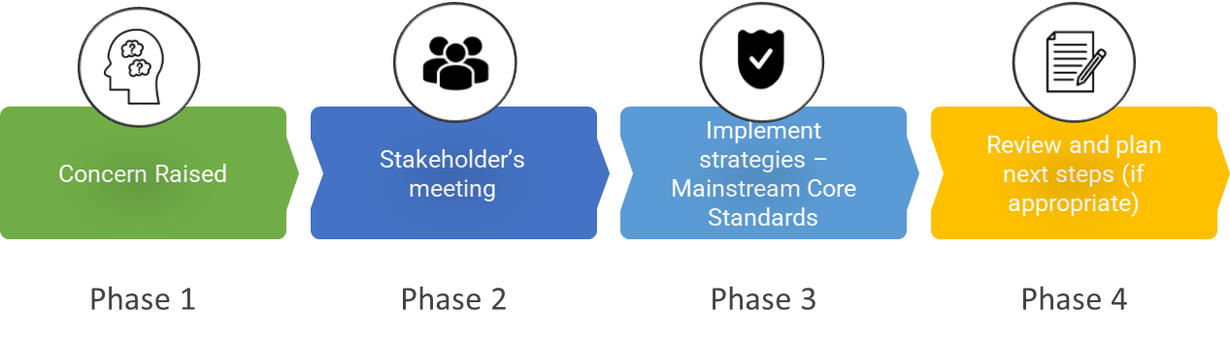

|  |  |
| --- | --- |
| **Phase 1** | If you think your child might have SEND, raise your concern with the school so that the SENCO is aware.  Explain how parents can get in touch with their child’s teacher/SEND team here. |
| **Phase 2** | We will meet with you to discuss your concerns and try to get a better understanding of what your child’s strengths and difficulties are. Together we will decide what outcomes to seek for your child and agree on next steps. We will make a note of what’s been discussed and add this to your child’s record. |
| **Phase 3** | We will implement the agreed strategies and monitor these over an agreed period of time. These are likely to be universal strategies set out in the mainstream core standards. A copy of this can be found here: <https://www.kelsi.org.uk/__data/assets/pdf_file/0005/117257/Special-educational-needs-mainstream-core-standards-guide-for-parents.pdf> . This will initiate the ‘Graduated Approach’ where support will be continually reviewed. See next page for more details. |
| **Phase 4** | If we decide that your child needs SEND support, we will formally notify you and your child will be added to the school’s SEND register. They will receive additional support and this will be reviewed using the assess, plan, do, review model. |

# 4. What happens if the school identifies a need?

Explain your school’s approach here. Insert details about how your school identifies pupils with SEND. Please note, the below are suggestions only.

The same process is followed if a concern is raised by the school.



All our class teachers are responsible for the monitoring of all pupils who have been identified as having SEND. They also review those who are not making the expected level of progress in their schoolwork or socially. This might include [insert examples such as reading, writing, number work].

If the teacher notices that a pupil is having difficulties, they try to find out if the pupil has any gaps in their learning. If they can find a gap, the school will provide appropriate support. Pupils who don’t have SEND usually make progress quickly once the gap in their learning has been filled.

If the pupil is still finding it difficult to make the expected progress, the teacher will talk to the SENCO, and will contact you to discuss the possibility that your child has SEND, and the school will follow the graduated approach (see previous page).

# 5. How will the school measure my child’s progress?

Explain your school’s approach here. Insert details about how your school assesses and reviews pupils’ progress. Please note, the below are suggestions only.

We will follow the ‘graduated approach’ to meeting your child’s SEND needs.

The graduated approach is a 4-part cycle of **assess, plan, do, review**.

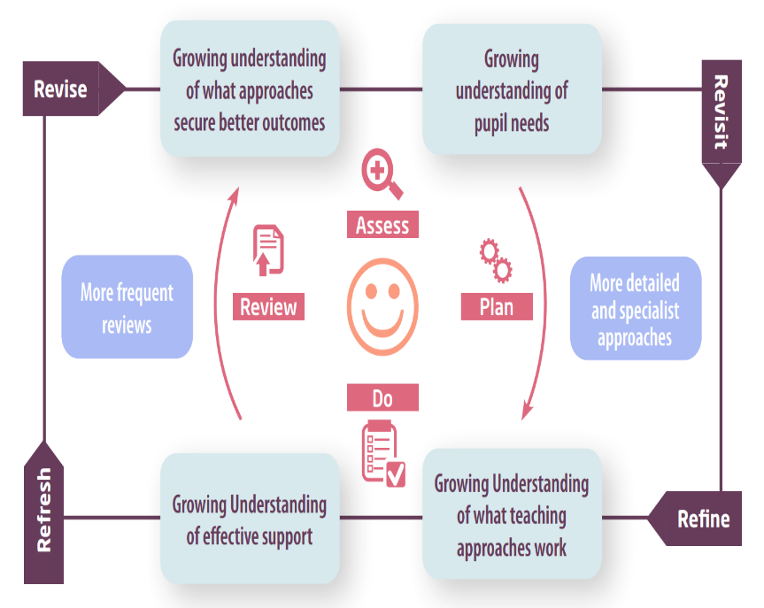

|  |  |
| --- | --- |
| **Assess** | If your child is not making the expected level of progress, we will make an assessment to find out what strengths and difficulties your child has. We will ask for you and your child’s input, as well as getting help from external professionals where necessary. |
| **Plan** | In discussion with you and your child, we will decide what outcomes we are hoping to achieve. We will make a plan of the support we will offer your child to help them meet those outcomes. We will make a record of this and share it with you and all relevant school staff. |
| **Do** | We will put our plan into practice.  The class teacher, with the support of the SENCO, will be responsible for working with your child on a daily basis, and making sure the support we put in place is having the impact we intended. |
| **Review** | We will assess how well the support we put in place helped the pupil to meet the outcomes we set. We will use our improved understanding of your child’s needs to improve the support we offer; this may mean the Plan, Assess, Do, Review cycle continues. |

# 6. How will I be involved in decisions made about my child’s education?

We will provide half-termly/termly/annual reports on your child's progress [annually at a minimum].

A member of staff who knows your child well will meet you [insert frequency here – at a minimum 3 times a year], to:

* Set clear outcomes for your child’s progress
* Review progress towards those outcomes
* Discuss the support we will put in place to help your child make that progress
* Identify what we will do, what we will ask you to do, and what we will ask your child to do

The SENCO may also attend these meetings to provide extra support.

We know that you’re the expert when it comes to your child’s needs and aspirations. So, we want to make sure you have a full understanding of how we’re trying to meet your child’s needs, so that you can provide insight into what you think would work best for your child.

We also want to hear from you as much as possible so that we can build a better picture of how the SEND support we are providing is impacting your child outside of school.

If your child’s needs or aspirations change at any time, please let us know right away so we can keep our provision as relevant as possible.

If you have concerns that arise between these meetings, please contact XXXXXXXXX. Explain how parents can get in touch with their child’s class teacher here / SENCO / Key worker.

# 7. How will my child be involved in decisions made about their education?

The level of involvement will depend on your child’s age and individual needs. We recognise that no two pupils are the same, so we will decide on a case-by-case basis, with your input.

We may seek your child’s views by asking them to:

* Attend meetings to discuss their progress and outcomes
* Prepare a presentation, written statement, video, drawing, etc.
* Discuss their views with a member of staff who can act as a representative during the meeting
* Complete a survey



8. How will the school adapt its teaching for my child?

Explain your school’s approach here. Describe your approach to adapting teaching, the curriculum and the learning environment. Please note, the below are suggestions only.

You may wish to link to your accessibility plan here – you must include information about your accessibility plan in this report and confirm that it covers increasing the extent to which disabled pupils can participate in the curriculum.

Your child’s teacher/s is/are responsible and accountable for the progress and development of all the pupils in their class.

High-quality teaching is our first step in responding to your child’s needs. We will make sure that your child has access to a broad and balanced curriculum in every year they are at our school.

We will adapt our approaches to how we teach to suit the way the pupil works best. There is no 'one size fits all’ approach to adapting the curriculum, we work on a case-by case basis to make sure the adaptations we make are meaningful to your child and are guided by the Mainstream Core Standards in the first instance.

These adaptations may include: Adapt this list to suit your school’s approach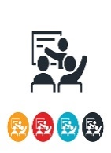

* Adapting our approaches, for example, giving longer processing times, pre-teaching of key vocabulary, reading instructions aloud, etc.



* Adapting our resources and staffing



* Using recommended aids, such as laptops, coloured overlays, visual timetables, larger font, etc.



* Teaching assistants or support staff will support pupils appropriately depending on their presentation of need



* Scaffolding lesson materials

**We may also provide the following interventions:**

Insert list of interventions provided at your school

These interventions are part of our contribution to Kent County Council’s local offer.

# 9. How will the school evaluate whether the support in place is helping my child?

Explain your school’s approach here. Describe how your school evaluates the effectiveness of the provision for pupils with SEND. Please note, the below are suggestions only.

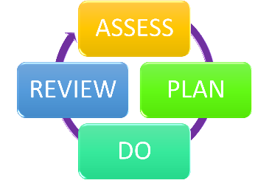We will evaluate the effectiveness of provision for your child by:

* Reviewing their progress towards their goals each term
* Reviewing the impact of interventions after [number of] weeks
* Using pupil questionnaires
* Monitoring by the SENCO
* Using provision maps to measure progress
* Holding an annual review (if they have an education, health and care (EHC) plan)

# 10. How will the school ensure my child has appropriate resources?

Explain your school’s approach here. Describe your funding arrangements and the process for securing staffing time, equipment and facilities to support pupils with SEND.

It may be that your child’s needs mean we need to provide additional resources such as:

* Additional resources to support their learning
* Adaptations to in class support
* Further training for our staff
* External specialist expertise

Where appropriate, we will consult with external agencies to get recommendations on what will best help your child access their learning and use our best endeavours to ensure these are supplied.

# 11. How will the school make sure my child is included in activities alongside pupils who don’t have SEND?



Explain your school’s approach here. Describe how you make sure there are no barriers to your pupils with SEND enjoying the same activities as other pupils in your school, including physical activities. Please note, the below are suggestions only.

The expectation is that all schools providing an inclusive provision for all pupils. It may be necessary for some pupils to receive interventions in addition to a broad and balanced curriculum.

All of our extra-curricular activities and school visits are available to all our pupils, including our before and after-school clubs.

All pupils are encouraged to go on our school trips, including our residential trip(s) to [name of educational visit].

All pupils are encouraged to take part in [sports day/school plays/special workshops – edit as appropriate].

No pupil is ever excluded from taking part in these activities because of their SEN or disability and we will make whatever reasonable adjustments are needed to make sure that they can be included.

# 12. How does the school make sure the admissions process is fair for pupils with SEN or a disability?

Explain your school's approach to admissions for prospective pupils with SEN or a disability, i.e.

* Your arrangements for the admission of prospective pupils with a disability and prospective pupils with SEN
* How you make sure that all prospective pupils whose EHC plan names the school will be admitted before any other places are allocated
* An explanation of how your oversubscription criteria avoid unfairly disadvantaging prospective pupils with a disability or special educational needs

# 13. How does the school support pupils with disabilities?



Add information here about how you support pupils with disabilities. Include information about:

* The steps you have taken to prevent disabled pupils from being treated less favourably than other pupils

See Accessibility Plan for more information (add link to your school’s)

You’re disabled under the Equality Act 2010 if you have a physical or mental impairment that has a ‘substantial’ and ‘long-term’ negative effect on your ability to do normal daily activities.

# 14. How will the school support my child’s mental health and emotional and social development?

Explain your school’s approach here. Include any extra pastoral support arrangements for listening to the views of pupils with SEND and what measures you have in place to prevent bullying. Please note, the below are suggestions only.

We provide support for pupils to progress in their emotional and social development in the following ways:

* Pupils with SEND are encouraged to be part of the school council
* Pupils with SEND are also encouraged to be part of [name of] club to promote teamwork/building friendships
* We provide extra pastoral support for listening to the views of pupils with SEND by [insert your provision]
* We run a nurture club for pupils who need extra support with social or emotional development
* We have a ‘zero tolerance’ approach to bullying. We prevent bullying in the school by [insert measures]

# 15. What support is in place for looked-after and previously looked-after children with SEND?



Insert name, contact details (and photograph, if the staff member agrees) of the designated teacher for looked-after children and previously looked-after children here. If this person is your SENCO, amend the below accordingly.

[Insert name of designated teacher] will work with [insert name of SENCO], our SENCO, to make sure that all teachers understand how a looked-after or previously looked-after pupil’s circumstances and their SEND might interact, and what the implications are for teaching and learning.

Pupils who are looked-after or previously looked-after will be supported much in the same way as any other child who has SEND. However, looked-after pupils will also have a personal education plan (PEP). We will make sure that the PEP and any SEND support plans or EHC plans are consistent and complement one another.

# 16. What support will be available for my child as they transition between classes or settings or in preparing for adulthood?

Insert your approach for pupils moving between years, schools, phases, and onto adulthood Insert the ways your school prepares pupils for each transition. Please note, the below are suggestions only.

Between years

To help pupils with SEND be prepared for a new school year we:

* Ask both the current teacher and the next year’s teacher to attend final meeting of the year when the pupil’s SEND is discussed
* Schedule lessons with the incoming teacher towards the end of the summer term

Between schools

When your child is moving on from our school, we will ask you and your child what information you want us to share with the new setting.

Between phases (for primary schools)

The SENCO of the secondary school will come into our school for a meeting with our SENCO. They will discuss the needs of all the pupils who are receiving SEND support.

Pupils will be prepared for the transition by:

* Practising with a secondary school timetable
* Learning how to get organised independently
* Plugging any gaps in knowledge

Between phases (for secondary schools)

The SENCO of the primary school meets with our SENCO to discuss the needs of the incoming pupils near the end of the summer term.

We arrange meetings with the parents of incoming pupils to discuss how we can best welcome their child into our community.

We set up new pupils with a buddy from the year above to help them get settled in and make friends.

Onto adulthood (for secondary schools)

We provide all our pupils with appropriate advice on paths into work or further education.

We work with the pupil to help them achieve their ambitions, which can include goals in higher education, employment, independent living and participation in society.

# 17. What support is available for me and my family?

If you have questions about SEND, or are struggling to cope, please get in touch to let us know. We want to support you, your child and your family.

To see what support is available to you locally, have a look at your local authority’s [insert the name or names of local authorities in your catchment area] local offer. [Insert name of local authority/ies] publishes information about the local offer on their website:

Link off to the local offers of all the local authorities in your catchment area.

Our local special educational needs and disabilities information advice and support services (SENDIASS) organisations are:

Link off to all [local SENDIASS organisations](https://councilfordisabledchildren.org.uk/what-we-do-0/networks/information-advice-and-support-services-network/find-your-local-ias-service) in your catchment area.

Local charities that offer information and support to families of pupils with SEND are:

Link off to any local charities supporting families of pupils with SEND, including contact details.

National charities that offer information and support to families of pupils with SEND are:

* [IPSEA](https://www.ipsea.org.uk/)
* [SEND family support](https://sendfs.co.uk/)
* [NSPCC](https://www.nspcc.org.uk/keeping-children-safe/support-for-parents/supporting-children-special-educational-needs-disabilities/)
* [Family Action](https://www.family-action.org.uk/what-we-do/children-families/send/)
* [Special Needs Jungle](https://www.specialneedsjungle.com/)

# 18. What should I do if I have a complaint about my child’s SEND support?

Link off to your school’s complaints procedure.

Explain your school’s approach here, including an outline of how complaints will be handled, and how parents can complain.

Complaints about SEND provision in our school should be made to the [class teacher/SENCO/headteacher] in the first instance. They will then be referred to the school’s complaints policy.

If you are not satisfied with the school’s response, you can escalate the complaint. In some circumstances, this right also applies to the pupil themselves.

To see a full explanation of suitable avenues for complaint, see pages 246 and 247 of the [SEND Code of Practice](https://www.gov.uk/government/publications/send-code-of-practice-0-to-25).

If you feel that our school discriminated against your child because of their SEND, you have the right to make a discrimination claim to the first-tier SEND tribunal. To find out how to make such a claim, you should visit: <https://www.gov.uk/complain-about-school/disability-discrimination>

You can make a claim about alleged discrimination regarding:

* Admission
* Exclusion
* Provision of education and associated services
* Making reasonable adjustments, including the provision of auxiliary aids and services

Before going to a SEND tribunal, you can go through processes called disagreement resolution or mediation, where you try to resolve your disagreement before it reaches the tribunal. Insert contact details of the disagreement resolution and mediation services for Kent.

# 19. Supporting documents

* *Equality Information and Objectives Policy*
* *Child protection and safeguarding policy*
* *Behaviour Policy*
* *Accessibility Plan*
* *Attendance and punctuality policy*
* *SEND policy*
* *SEN & Disabilities Code Of Practice 2015*
* *Mainstream Core Standards*

# 20. Glossary

* **Access arrangements** – special arrangements to allow pupils with SEND to access assessments or exams
* **Annual review** –an annual meeting to review the provision in a pupil’s EHC plan
* **Area of need** – the 4 areas of need describe different types of needs a pupil with SEND can have. The 4 areas are communication and interaction; cognition and learning; physical and/or sensory; and social, emotional and mental health needs.
* **CAMHS** – child and adolescent mental health services
* **Differentiation** – when teachers adapt how they teach in response to a pupil’s needs
* **EHC needs assessment** – the needs assessment is the first step on the way to securing an EHC plan. The local authority will do an assessment to decide whether a child needs an EHC plan.
* **EHC plan** –an education, health and care plan is a legally-binding document that sets out a child’s needs and the provision that will be put in place to meet their needs.
* **First-tier tribunal/SEND tribunal** – a court where you can appeal against the local authority’s decisions about EHC needs assessments or plans and against discrimination by a school or local authority due to SEND
* **Graduated approach** – an approach to providing SEND support in which the school provides support in successive cycles of assessing the pupil’s needs, planning the provision, implementing the plan, and reviewing the impact of the action on the pupil
* **Intervention** – a short-term, targeted approach to teaching a pupil with a specific outcome in mind
* **Local offer** – information provided by the local authority which explains what services and support are on offer for pupils with SEND in the local area
* **Outcome** – target for improvement for pupils with SEND. These targets don't necessarily have to be related to academic attainment
* **Reasonable adjustments** – changes that the school must make to remove or reduce any disadvantages caused by a child’s disability
* **SENCO** – the special educational needs co-ordinator
* **SEN** – special educational needs
* **SEND** – special educational needs and disabilities
* **SEND Code of Practice** – the statutory guidance that schools must follow to support pupils with SEND
* **SEND information report** – a report that schools must publish on their website, that explains how the school supports pupils with SEND
* **SEND support** – special educational provision which meets the needs of pupils with SEND
* **Transition** – when a pupil moves between years, phases, schools or institutions or life stages