|  |
| --- |
| ANNUAL ReVIEW PROTOCOL |
|  |





 Annual Review Protocol:

This protocol should be read in conjunction with

The SEND Code of Practice.

### **ANNUAL REVIEWS PROTOCOL**

Our Annual Review Protocol aims to provide an overview of the key duties which apply to educational providers as set out in:

* [The Children & Families Act 2014](https://www.legislation.gov.uk/ukpga/2014/6/section/44):
* [SEND Regulations 2014](https://www.legislation.gov.uk/uksi/2014/1530/contents/made);
* [The SEND Code of Practice](https://assets.publishing.service.gov.uk/media/5a7dcb85ed915d2ac884d995/SEND_Code_of_Practice_January_2015.pdf).

This protocol should be read in conjunction with The SEND Code of Practice.

WHAT IS AN ANNUAL REVIEW?

The annual review is required to check all sections of the EHCP not just the educational Outcomes and provision. It can provide an opportunity for parents and young people to request changes and updates. The annual review meeting must focus on the young person’s progress towards achieving the outcomes specified in their plan.

The annual review meeting typically takes place within the educational setting and informs the Local Authority (LA), which is in charge of the review process. In Kent, schools or settings usually conduct the annual review meeting.

The annual review meeting must be undertaken in partnership with the student and their parent(s)/carer(s) and must take account of their views, wishes and feelings, including the right to request a personal budget each year.

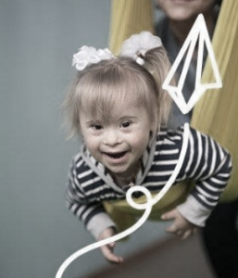Kent County Council will provide a school/setting with a list of all students and their review dates each term. Following the annual review meeting, the Kent County Council will make the decision whether to maintain, amend or cease the EHC plan.

*“We want to put in place a radically different system to support better life outcomes for young people; give parents confidence by giving them more control; and transfer power to professionals on the front line and to local communities.”*

[(The Green Paper)](https://assets.publishing.service.gov.uk/government/uploads/system/uploads/attachment_data/file/198141/Support_and_Aspiration_Green-Paper-SEN.pdf)

#### ANNUAL REVIEW LEGISLATION: The “MUST” HAVES:

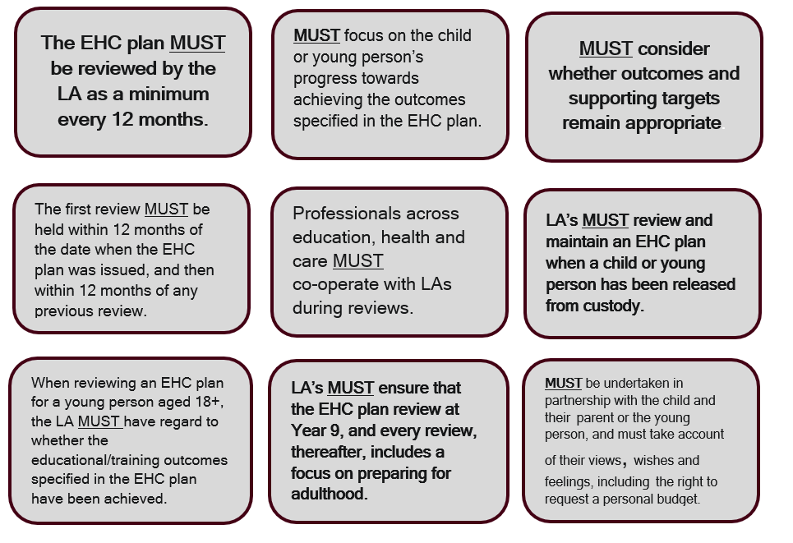

### **Connecting “THE GOLDEN THREAD”:**

### **THE IMPORTANCE OF OUTCOMES AND ASPIRATIONS**

The annual review must actively monitor the child or young person’s progress towards outcomes and longer-term aspirations.

**We know that:**

• Compared with their peers, children and young people who are disabled or who have SEND are considerably more likely to be at risk of poorer outcomes.

• They are less likely to achieve well at school and are four times less likely to participate in higher education.

• Pupils with SEND are more than twice as likely to be eligible for free school meals than their peers; and pupils with SEND are more likely to receive a permanent exclusion or a fixed-period exclusion than pupils with no identified SEND.

• Looked after children are three-and-a-half times more likely to have SEND compared with all children.

**ANNUAL REVIEW LEGISLATION: TRANSFERS BETWEEN PHASES:**

For transfers into or between schools, reviews and amendments must be completed by **15th February** in the calendar year of the transfer at the latest.

The key transfers are:

• early years provider to school

• infant to junior school

• primary to middle school

• primary to secondary school

• middle to secondary school

• For young people moving from secondary school to a Post-16 institution or apprenticeship, the review and any amendments to the EHC plan (including specifying the Post-16 provision and naming the institution) must be completed by **31st March** in the calendar year of the transfer.

• For young people moving between Post 16 institutions, the review process should normally be completed by **31st March** where a young person is expected to transfer to a new institution in the new academic year.

### 

### **ANNUAL REVIEW PROCESS: WHERE TO BEGIN?**

**STARTING THE PROCESS:**

**At least 2 weeks before the meeting** invitations to attend the Annual Review must be sent to:

• Parent or young person

• EY provider, headteacher or principal

• LA officer (education)

• Health care professional

• LA Officer (social care)

• Any other individuals relevant to the review.

**THE ANNUAL REVIEW PROCESS – PREPARING INFORMATION:**

**At least 2 weeks before the meeting information and advice must be** obtained from all those **invited and circulated to all those invited**. This information and advice should:

• Provide details about the child or young person’s progress and their access to teaching and learning.

• Consider whether the current special educational provision is effective.

• Consider whether the current health and social care provision is effective.

The information and advice from young people or professionals can make suggestions about changes that should be made to the EHC plan – this is especially important where amendments are sought.

**THE ANNUAL REVIEW PROCESS – PLANNING THE MEETING:**

• Consider where the meeting will take place to get the best outcome.

• Enable parents and the child or young person to have their say – does the environment encourage them to do this?

• Do parents and the child or young person know how they can be supported?

**THE ANNUAL REVIEW PROCESS - DURING THE MEETING:**

• Consider the child or young person’s progress towards the outcomes and whether they are still appropriate.

• Consider what provision is required to help the child or young person prepare for adulthood and independent living. Review any interim targets set by the early year’s provider, school or college or other education provider.

• Set new interim targets for the coming year and, where appropriate, agree new outcomes

• Take account of the views, feelings and wishes of the child, young person, and parent, including their right to a personal budget.

• Discuss any alterations in arrangements for personal budget/direct payments.

**THE ANNUAL REVIEW PROCESS - AFTER THE MEETING:**

**Within 2 weeks of the review meeting** the LA or the headteacher/principal must send a written report to all invitees setting out:

• Recommendations on any amendments to be made to the EHC plan.

• Any difference between those recommendations and the recommendations of others attending the meeting – this is important for parents to see easily.

• All the information and advice obtained about the child or young person.

**SUMMARY OF ANNUAL REVIEW PROCEDURES:**

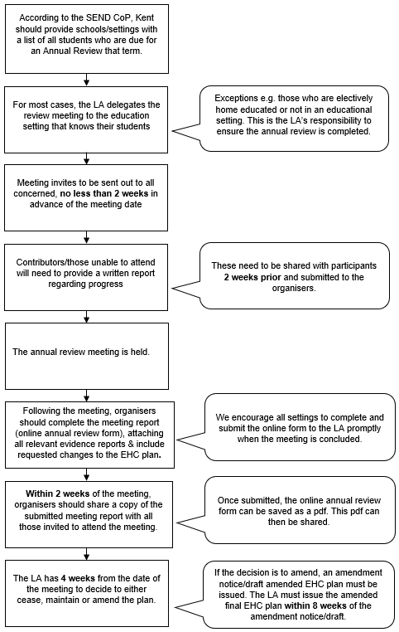

**WHAT HAPPENS NEXT?**

Within **four weeks** of the review meeting, Kent County Council will decide whether to:

1. Maintain the EHC plan in its current form providing families with information about their rights to mediation, disagreement services, and time scales.
2. Amend the EHC plan An amendment notice /draft plan must be sent to the parents/young people showing the proposed amendments and the evidence that supports it as well as the original EHC plan. The parents/young people must be told of their rights including requesting a particular school and/or personal budget, give **15 days** for comments or representations on the proposed changes. We must issue the amended EHC plan within **8 weeks** of the original amendment notice.
3. The decision to cease the EHC plan providing families with information about their rights to mediation, disagreement services, and time scales.

**WHEN DOES THE PROCESS DIFFER?**

1. **PREPARING FOR ADULTHOOD (PfA):**

• All reviews from Y9 onwards (and preferably before) must include a focus on PfA.

• Recording the wishes, views and feelings of children and young people is an important part of the review. LA’s and others have a duty to support and involve the young person and his or her parent and pay regard to their views, wishes and feelings.

• Representatives of post-16 organisations should be invited to the review, particularly where the young person has expressed a desire to attend a particular institution.

• The review meeting should have a particular focus on options and choices for the next phase of education.

• As the young person is nearing the end of formal education and the EHC plan is likely to be ceased within the next 12 months, there should be a focus on good exit planning.

1. **LOOKED AFTER CHILDREN:**

• Ensure that where possible the EHC plan Annual Review coincides with one of the Care Plan reviews, e.g. PEP which feeds into review of the wider Care Plan.

• Work closely with social workers to ensure that transitions from being looked after to returning home are managed effectively.

• Consider if it is appropriate for a long-term carer to take on the responsibility for managing a social care personal budget.

1. **RELEASE FROM DETENTION:**

• An LA cannot cease an EHC plan because a young person has been given a custodial sentence.

• If a detained young person has an EHC plan before being detained, the home LA must arrange for the EHC plan to be made available to the detention institution who will be able to make arrangements for provision to be delivered as specified or similar to the EHC plan.

* The EHC plan cannot be amended or reviewed whilst the young person is in detention. A statutory annual review will be carried out by the LA when released from detention.

• Consider if it is appropriate for a long-term carer to take on the responsibility for managing a personal budget.

• If a Health Care plan for a detained young person specifies health care provision the health services commissioner for the custodial establishment must arrange appropriate health care.

1. **CHILDREN NOT ATTENDING SCHOOL OR OTHER INSTITUTION:**

• The local authority must arrange the meeting and invite: The child’s parent or young person, a LA SEND officer, a health service representative and a LA social care representative to the review and given at least 2 weeks’ notice of the date of the meeting.

• Other relevant individuals should also be invited e.g Youth Offending Team, job coaches and any other person whose attendance the LA considers appropriate.

• The review must focus on Outcomes and any changes needed to either the support or the Outcomes themselves.

• Children, young people and parents should be supported to engage fully in the review meeting.



1. **CHILDREN AGED 0 – 5:**

• LA’s should consider reviewing every 3 – 6 months to ensure

provision remains appropriate.

• More frequent reviews may not need to involve all professionals

every time depending on the child’s needs.

• The child’s parent must be fully consulted on any proposed changes

and made aware of their right to appeal to the Tribunal.

**MANAGING THE ANNUAL REVIEW PROCESS:**

Tick list – please use this to help manage the process

|  |  |
| --- | --- |
| **Action** | **Completed** |
| Set annual review meetings for all students in your setting with an EHC plan. |  |
| Agree date of annual review meeting with parents/carers & formally invite. |  |
| Inform LA of annual review meeting date(s). |  |
| Inform relevant professionals of annual review meeting date(s). |  |
| Issue reports/advice & meeting invitations at least two week in advance. |  |
| Hold the annual review meeting. |  |
| Complete and submit the digitised annual review form (ensuring that all supporting evidence has been upload. |  |
| Once the digitised form has been submitted, download a PDF copy of the completed form. Within two weeks of the annual review meeting, share/send a copy to all those invited to the meeting. |  |
| Set the date of the annual review meeting for the following year. |  |

**ANNUAL REVIEW FORM AND RESOURCES:**

* Link to Kelsi website for annual review form and resources:

<https://www.kelsi.org.uk/special-education-needs/special-educational-needs/education,-health-and-care/annual-reviews>

**USEFUL LINKS:**

* Preparing for Adulthood:
* [Preparing for Adulthood: EHC Planning - NDTi](https://www.ndti.org.uk/resources/preparing-for-adulthood-all-tools-resources/pfa-ehc-planning)
* Council for Disabled Children factsheets:
* [Participation%20Factsheet%205%20Final.pdf](https://councilfordisabledchildren.org.uk/sites/default/files/uploads/files/Participation%2520Factsheet%25205%2520Final.pdf)
* Contact advice:

<https://contact.org.uk/advice-and-support/education-learning/ehc-plans-assessments/annual-reviews/>

* An example of ensuring reviews are person-centred:

[Person-Centred-Reviews-booklet.pdf (linwood.bournemouth.sch.uk)](https://linwood.bournemouth.sch.uk/wp-content/uploads/2024/02/Person-Centred-Reviews-booklet.pdf)