

**Schools Financial Services**

*It all adds up to a great service, flexibility and peace of mind*



**Schools Financial Services**

**Academy Funding Template 2016-17 – Input Guidance**

**Academy Funding Template 2016-17 - Input Guidance**

Contents

‘Contents’ Tab 3

‘Home Tab 3

‘Early Years’ Tab 4

Early Years Funding 4

Early Years Pupil Premium (EYPP) 5

‘High Needs Mainstream’ Tab 6

‘Specialist Resourced Provision’ Tab 7

‘Growth Funding’ Tab 10

‘SRP Rates’ Tab 11

**PLEASE NOTE:**

The purpose of this document is to provide guidance to Academies in Kent when filling out the Kelsi Academy Funding Template 2016-17. *This template gives details of funding allocations that are the responsibility of the Local Authority (LA) to fund directly.*

This funding relates to a budget allocation for the financial year April 2016 to March 2017. An academy’s financial year runs for the period September to August. Therefore, when budget setting, the figures from the Academy Funding Template 2016-17 can be used for the 7 month period from September 2016 to March 2017.

However, estimates will need to be used for the 5 month period from April 2017 to August 2017 and these should be based on local knowledge and expectations.

**Academy Funding Template 2016-17 - Input Guidance**

At the bottom of the spreadsheet there are a number of tabs.



# ‘Contents’ Tab

This tab is for information only and provides details about the purpose of each of the other tabs within the template and hyperlinks to them.

# ‘Home Tab

On the ‘Home Tab select the Academy DfE number in cell F11 at the top of the sheet. The number can either be typed in directly or selected using the drop-down menu.

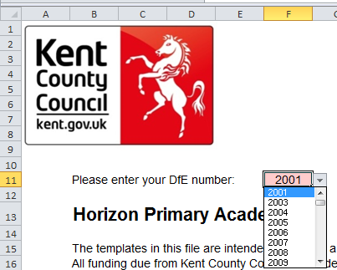

# ‘**Early Years’ Tab**

## Early Years Funding

This tab provides an Early Years Budget Estimation for 2016/17.

If the school has Early Years Funding (Nursery), the calculation of the school’s hourly rate will be shown near the top of the sheet, made up of a base rate, a Qualified Teacher Supplement and a Disadvantage Supplement.

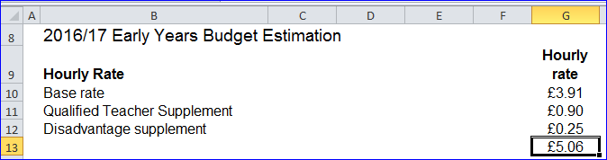

Enter Early Years pupil numbers in the pink-shaded cells in the table below by putting the number of pupils against the number of Early Years Hours that they attend school for each term.

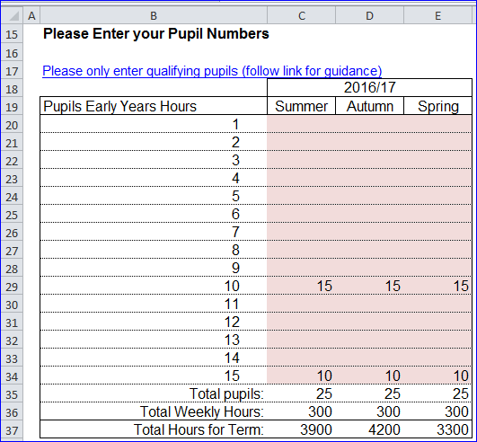

Follow the link in row 17 for guidance on determining eligibility for Free Early Education for 3 to 4 year olds and what constitutes a qualifying pupil.

Below this section, a summary table will provide a Total 2016/17 Estimated Budget figure in cell G46.

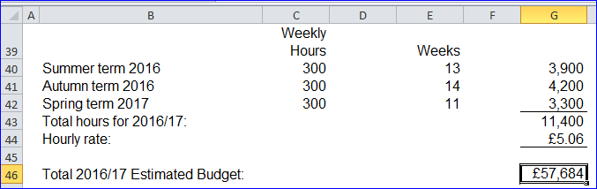

## Early Years Pupil Premium (EYPP)

Lower down the sheet there is a similar table to fill out for EYPP, and a link to relevant guidance on row 52.

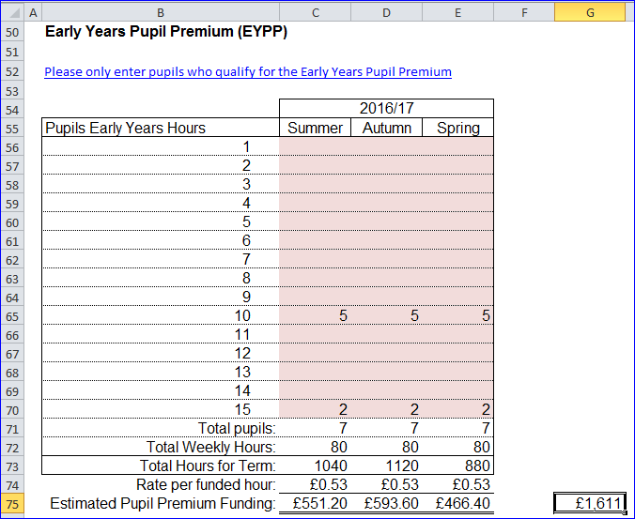

Fill the table out by entering the number of pupils against their weekly hours for each term.

A Total 2016/17 Estimated Pupil Premium Funding figure will show in cell G75.

# ‘High Needs Mainstream’ Tab

Academies with High Needs Mainstream pupils will need to enter pupil data on this tab.

When entering data on this tab it may be useful to refer to [this](https://shareweb.kent.gov.uk/Documents/KELSI/Finance/High%20Needs%20Consultation%20vfinal.pdf) consultation document.

The tables to the right of the pupil data will then populate with any Element 3 top up funding, Notional SEN budget top up funding & Post 16 Element 2 funding.

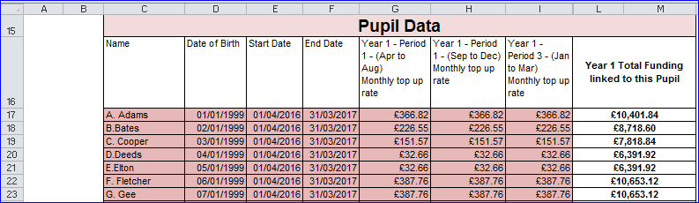

1) Enter the pupil names in Column C and dates of birth in Column D.

**N.B. Date of Birth MUST be entered for the funding to be calculated correctly.** When estimating future years budgets when a DOB may not be known use a fictitious date but ensure that it accurately reflects whether the pupil is Pre or Post 16

2) Placement Start and End dates are already filled in and assume the pupil will be at the school for the full financial year. These can be changed as necessary.

3) Enter the Year 1 Summer, Autumn and Spring Monthly top up rates in columns G, H and I respectively. Monthly top up rates appear in the confirmation letters received by SENCOs, sent out by the SEN resources team

It is prudent to initially forecast the same rates for each of the periods in Columns G to K and then update them as necessary.

At the bottom of this table in cell L/M83 the total funding linked to the pupils entered in the table will be shown.

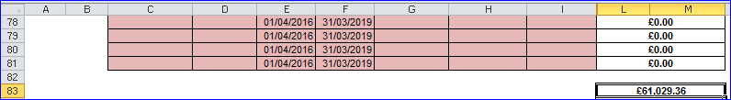

This figure is then broken down further in the tables to the right, between Element 3 top up and Notional SEN budget top up and Post 16 Element 2, with total in cells AA83, AO85 and BC83 respectively.

At the top of the sheet, above the Element 3 top up table, the workings for the Notional SEN budget top up rate are shown.

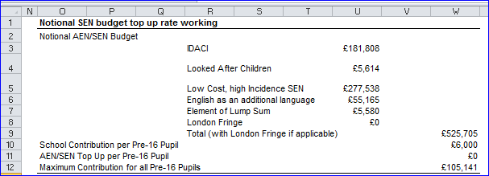

To the right of the Notional SEN budget top up table, there is another table that shows any Extra top up due to the 20% rule



# ‘Specialist Resourced Provision’ Tab

Academies with Specially Resourced Provisions (SRPs) will need to enter data for those pupils in the pink–shaded cells in the Element 3 input table on this tab.

1) In row J, the drop down menu can be used to select the correct designation for each pupil (only 3 schools have two SRPs so the majority will use ‘designation 1’).

2) In row K the pupil Surname is entered, Forename in row L and Date of Birth (D.O.B) in row M.

3) Columns N and O will then use the DOB figure to auto-populate with a Pre or Post 16 indicator for the summer and winter terms.

4) Placement start (row P) and end dates (row Q) can be amended as necessary. The table will then automatically calculate any Place Plus funding for High Needs Pupils in Resourced Provision.

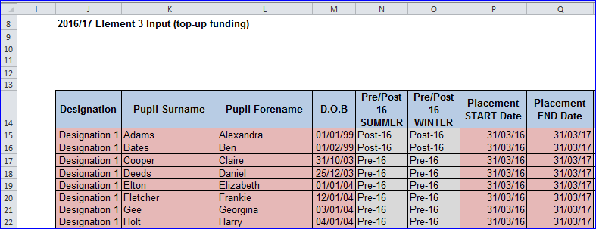

5) A Pre 16 Element 1 Funding figure will appear in cell H20, and a figure for Element 2 in cell H24, and a Total figure in cell H26

6) Post 16 Element 1 Funding is already included within the 16-19 allocation. A Post 16 Element 2 figure will appear in cell H37, and a Total figure in cell H41.

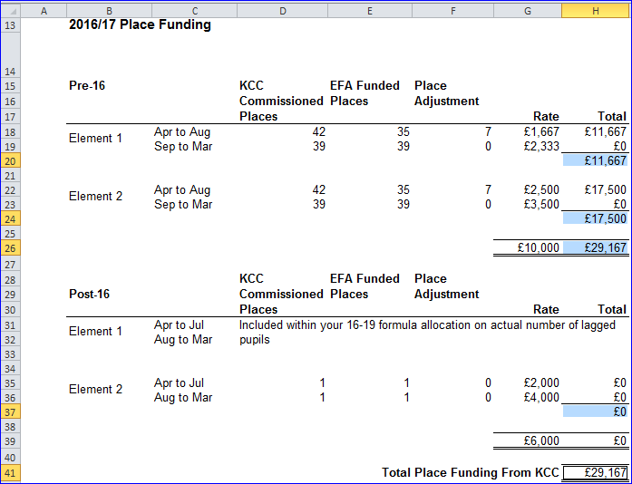

*Lagged pupil numbers: This is a count of the number of pupils participating in the previous academic year.*

Excess Place Funding (the number of actual pupils above the agreed place numbers) will be shown in the table below.

1) Pre-16 Excess pupil numbers appear in column C, with the funding in Column D.

2) Post-16 Excess pupil numbers are shown in Column E, with the associated funding in column F.

3) Total monthly funding then appears in Column G, with an annual total in cell G62.

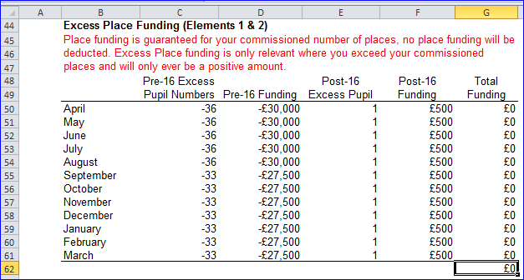

Below this there is an Element 3 Top-up Funding table, with an annual total in cell C80.

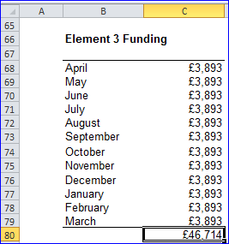

To the right of this is a Summary table, with Total 2016/17 SRP funding shown in cell G73.

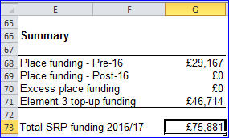

# ‘Growth Funding’ Tab

The Growth Funding Estimator on this tab calculates Rising Roll Funding as well as Reorganisation Funding, if applicable.

1) In cell E20 enter the number of pupils in Year R on the October 2016 census.

2) Schools eligible for Reorganisation Funding will receive email notification of any amounts due and can populate the pink shaded cells in row H with the relevant information.

3) A total figure for the year will appear in cell H26.

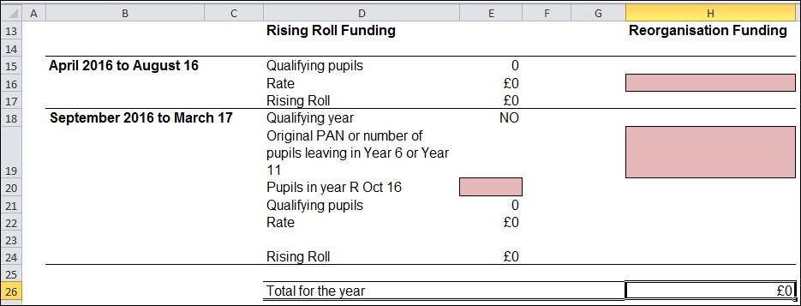

# 

# ‘SRP Rates’ Tab

This tab is for information only and explains how SRP rates have been calculated for each of the eligible schools. No data needs to be entered onto this sheet.